NUMBESR WORKSHEET

Write the following numbers in digits

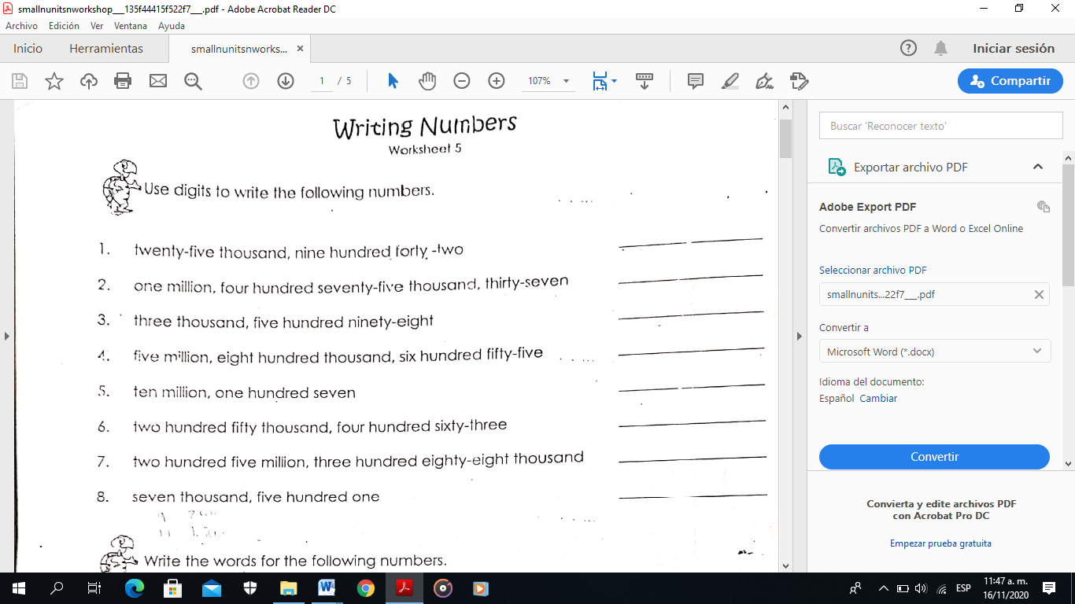

Write the following numbers in letters

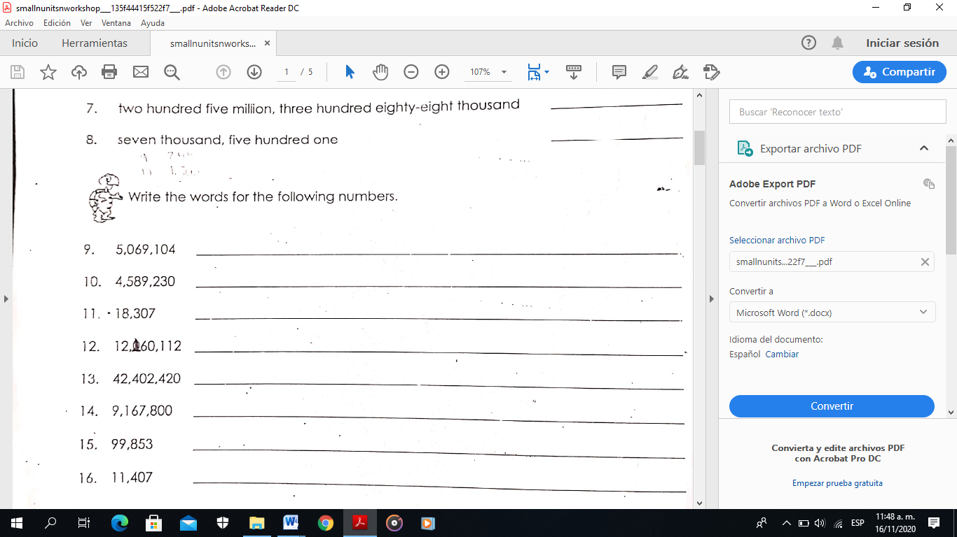

2. Use the ordinal numbers for the following exercises

1. April is the_______________month of the year.
2. June is the__________________month of the year.
3. January is the_______________month of the year.
4. July is the________________month of the year.
5. February is the_____________month of the year.

2.Using the ordinal numbers write the correct date

1. I was born on ________________________________________________________________

2. . Mother’s day is celebrated on ____________________________________________________

3. Christmas is celebrated on ______________________________________________________

4. Halloween is celebrated on ______________________________________________________

5. Independence Day is celebrated on _______________________________________________

Match the time.

|  |  |  |
| --- | --- | --- |
| 1. It’s three o’clock. |  | a. 12.35 |
| 2. It’s a quarter past eight. |  | b. 8.05 |
| 3. It’s ten thirty. |  | c. 11.25 |
| 4. It’s five to five. |  | d. 1.58 |
| 5. It’s nine twenty five. |  | e. 8.15 |
| 6. It’s twenty-five to eleven. |  | f. 4.55 |
| 7. It’s two to two. |  | g. 10.35 |
| 8. It’s eleven twenty-five. |  | h. 9. 25 |
| 9. It’s five past eight. |  | i. 10.30 |
| 10. It’s twelve thirty-five. |  | j. 3.00 |

. What time is it? Write in numbers.

1. It’s seven thirty - ………………….. 6. It’s ten past eleven-…………………….

2. It’s five to ten - …………………….. 7. It’s a quarter to three- ………………

3. It’s one to one - ……………………. 8. It’s four thirty-five - ………………….

4. It’s a quarter past three - ………. 9. It’s twelve o’clock - …………………….

5. It’s eight forty-five - ……………… 10. It’s two fifty-five. - …………………